## Merchant

Demo date: Oct. 15, 2024  
Scoping start date: Oct 14, 2024

MSA Signature Date: Oct 16, 2024  
Onboarding Kick Off Date: Oct 21, 2024

[If Exists] Opt Out Date:  
Go Live Date: Nov 8, 2024

GTM POC: Nick  
Implementation POC: Ariel

ERP: QBO

Tax Integration: No Tax

### 

### Key people at Merchant

### Accountant: Audrey Mathis

### CEO: Robert Iskander

### Customer service rep who is really involved: Jennifer Johnson, Tamara Rubbelke

* Account Receivable POC: Oleg Fedyk
* Billing POC: Audrey Mathis

### Etc.

### 

| Notes Sections [Ops International Team to Ignore] *(AE/ Implementation to fill)*   * Info on how merchant bills   + Platform/Implementation/Subscription Fee   + Some Usage * Is there any important merchant relationship information?  1) What is the merchant temperament? * Extremely nice and easy to work with 2) Is there a key POC: (i.e.: who is the buyer/decision maker?) * Robert Iskander and Audrey Mathis are main POCs 3) What are the Tabs features that the key POC cares about? * One platform for all things revenue. Syncing back to QBO. Automated invoicing, Rev Rec, and RENEWALS |
| --- |

### 

### Company summary *(AE to fill)*

Global Grid for Learning is a membership-based collaborative providing school and edtech vendors a foundation for digital transformation. It is offering a suite of cloud integration services to schools, financially sustained by hundreds of edtech vendors. It helps close the skills gap by connecting students, employers, and content providers with an efficient and cost-saving approach while the school's initiative focuses on school safety.

Goals (North star)  
*(AE/ Implementation to fill)*

What is the merchant's goal? What pain are we solving? Why are they buying Tabs?

Had Maxio and it just didn’t work with their acquisition. Goal is operating out of one platform for all things revenue. Renewal management is a huge value driver for them. Automated invoicing and contract management. Collections and dunning are also massive adds.

Is there an opt out clause? If so, what is the merchant looking for so they do not exercise it?  
No

### Billing model *(AE/ Implementation to fill)*

* Are there unique things about the customer creation process for this merchant?
* Information on how merchant bills
* How contract is broken up
* One off things to know about the merchant

### Contract Processing Steps *(Implementation/Success to fill)*

1. Steps to process

***There are 3 different types of contracts for this merchant***

**LuminTouch**

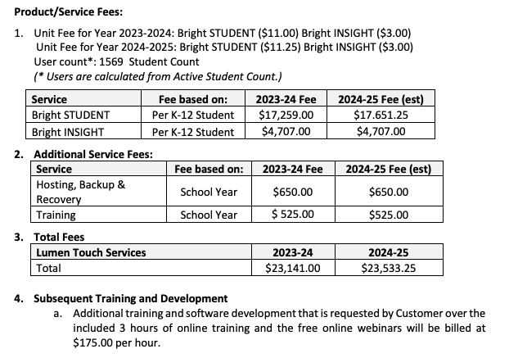

* These contracts are broken down into multiple year terms
* Everything in the **Service** column is 2 BTs - 1 for the first year and 1 for the second
  + Sometimes it is the same for both years and sometimes it is different
  + Annual up-front billing for each year
* Integration items map almost exactly to the the name of the item, with the exception:
  + Training = Bright - Training
  + Hosting = Lumin Hosting
* DO NOT PROCESS #4 from above image
* **For every annual BT after the 1st year, set as “Bill in advance, due on first of period”**

**GG4L**

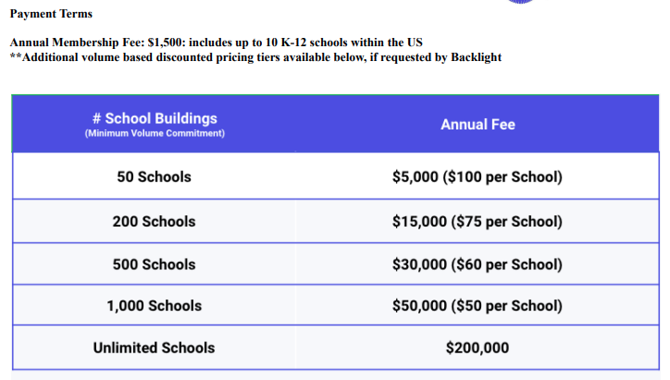

* These are annual upfront membership fees, outlined clearly in the payment terms section of the contract
* If there are 2 items outlined for the annual fee, separate them into two different BTs. For example:
  + 8K for Standard Roster Integration and 2K for Communications API

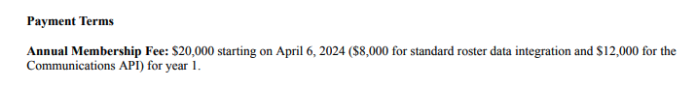

* In addition to this, there is an option for customers to add on new schools per the rates outlined in the tiers of the contract
  + **IGNORE THIS UPON INITIAL PROCESSING**
  + This information will be sent separately and will be processed as new BTs

**Quarterly amendments**

On a quarterly basis, GG4L will be sending Tabs data for adding additional schools for the GG4L contracts. This is going to be processed as flat BTs as opposed to going through usage because each item will need to be prorated and other BTs need to be adjusted as part of this process.

**Instructions**

Each contract lists the dollar amount per additional school for each tier. Based on the annual price outlined above the tier table, you will be able to detect what tier the customer is in, and therefore what price to use for the following instructions

1. GG4L will email CSV exports of additional schools that need to be charged.
2. Each CSV can have multiple lines. The relevant data we need from this is:
   1. Tabs Customer ID - to confirm the customer
   2. Organization - this will be the name of the BT
   3. Created: This will be the date used for proration

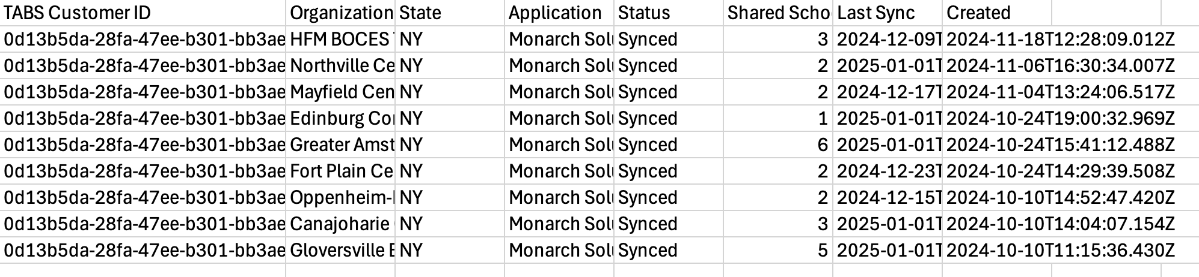

1. Create BTs
2. Adjust future annual BTs

**UPDATE: NO TIERS PER CONTRACT, RATE PER ADDITIONAL SCHOOL IS LOCKED IN**

* On a quarterly
* When new schools are added, they are charged at the per school rate from the table above
  + This data is tracked monthly, but they will invoice for these updates quarterly
  + When a new school is added, they only pay for that school once for the year
  + When a new school is billed, it is annualized for the year
  + At the end of the first year of the contract, all new schools are added to the annual fee for the next year
* At a specified cadence (monthly, quarterly, etc.), they will send us a list of all customers, schools added, what date the school started
* We will process all additional schools for each customer as a prorated BT,
* This will also get applied to the following year’s annual BT if there is another year left of the contract
* There is also a chart below that will outline additional school fees (seen above). This should be set up as a tiered BT
  + Use the # of School Buildings as the name of the Tier
  + Use the # of schools for thresholds
  + Use the parenthetical per school amount as the price per tier
    - If this does not exist for that contract, **please flag**
  + Ignore the Total Annual Fee
    - Ex: 50 Schools at $100 per school, ignore the $5,000
  + Quarterly in arrears
* Integration Item: Membership fee + cost
  + Their integration items have membership fee + cost associated in the name of the item. Map the membership fee to the item that matches to the cost
  + If the total annual membership cost is an amount that is not any of the options, leave it blank.
  + If there are 2 BTs for the membership fee, use the total Annual Member Fee to map for this (such as in the example above)
  + List available is below:

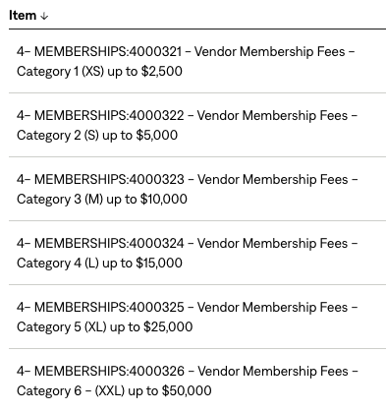

**Districts**

* These are all POs
* Process per the details on the PO
* Add PO # to invoice in garage

1. Anything to ignore in contracts?
2. Specifics processing things the merchant has requested that may differ by contract (e.g. always back-date invoice date to final day of the month)
3. Default Service Term
   1. If None Listed, Ops Default is 1 Year
4. Default Net Payment Terms
   1. If None, Ops Default is 0
5. Default Billing Frequency
   1. If None Listed, Ops Default is Monthly
6. How do we handle taxes as a line item?
   1. If None Listed, Ops Default is every tax line item becomes a BT

### Events Processing (if necessary) *(Implementation/Success to fill)*

NOT RELEVANT YET, ARIEL TO UPDATE WHEN WE CALIBRATE FOR THIS SEGMENT

* bill usage for use of a third party tool called vonage (SMS, phone services)
* vendor partners purchase vonage through GG4L
* some partners have this product baked into their actual agreement
* pay as you go

Integration Items Processing (if necessary)  
*(Implementation/Success to fill)*

* What are the instructions for assigning integration items?
* Example: All Statsig integrations items should be labeled as “Sales”
* Example: All “Pinata” integration items should be labeled as “Software Subscription Bundle” unless otherwise noted by Merchant

Post Processing Communications (if necessary)  
*(Implementation/Success to fill)*

* Does the Ops Team need to notify anyone on the team re: completion of processing batches in Implementation or Active phase?
* Who needs to be notified and when?
  + Example:
    - Who: Customer Success [Azmat Aziz] needs to be notified
    - Where: Messari internal merchant channel
    - When: contracts are processed [Merchant Phase: Active]

### Customer Information *(Implementation/Success to fill)*

* Any important information on specifics customers of this merchant
  + Special memo’s certain invoices require
  + Invoice changes due to merchant/customer relationship

### Feature Requests *(AE/Implementation/Success to fill)*

* Populating invoices with logo from different entities
  + GG4L acquired Lumen Torch. The are still billing Lumen Torch’s customers and asked if we could put that logo and billing address on the invoices
  + Customer management/confusion
  + Definitely a need to have but not urgent
* They track usage data in HS
  + They want to automatically pull usage data on a monthly basis from HS
  + Automated Process
  + Crawl, Walk, Run here
* Custom Fields per customer
  + Want Project ID and Sales Repopulated on the customer level
  + Sales reps involved in collections
  + During implementation

### Rewatch Calls *(AE/Implementation/Success to fill)*

* Disco (10/14/24):
  + <https://tabs.rewatch.com/video/jzg6pqv5wvcdf12j-nicholas-gatti-and-robert-iskander-october-14-2024>
* Custom Demo and Proposal (10/15/24):
  + https://tabs.rewatch.com/video/7rfl1oxo88ll7bpx-gg4l-tabs-custom-demo-october-15-2024